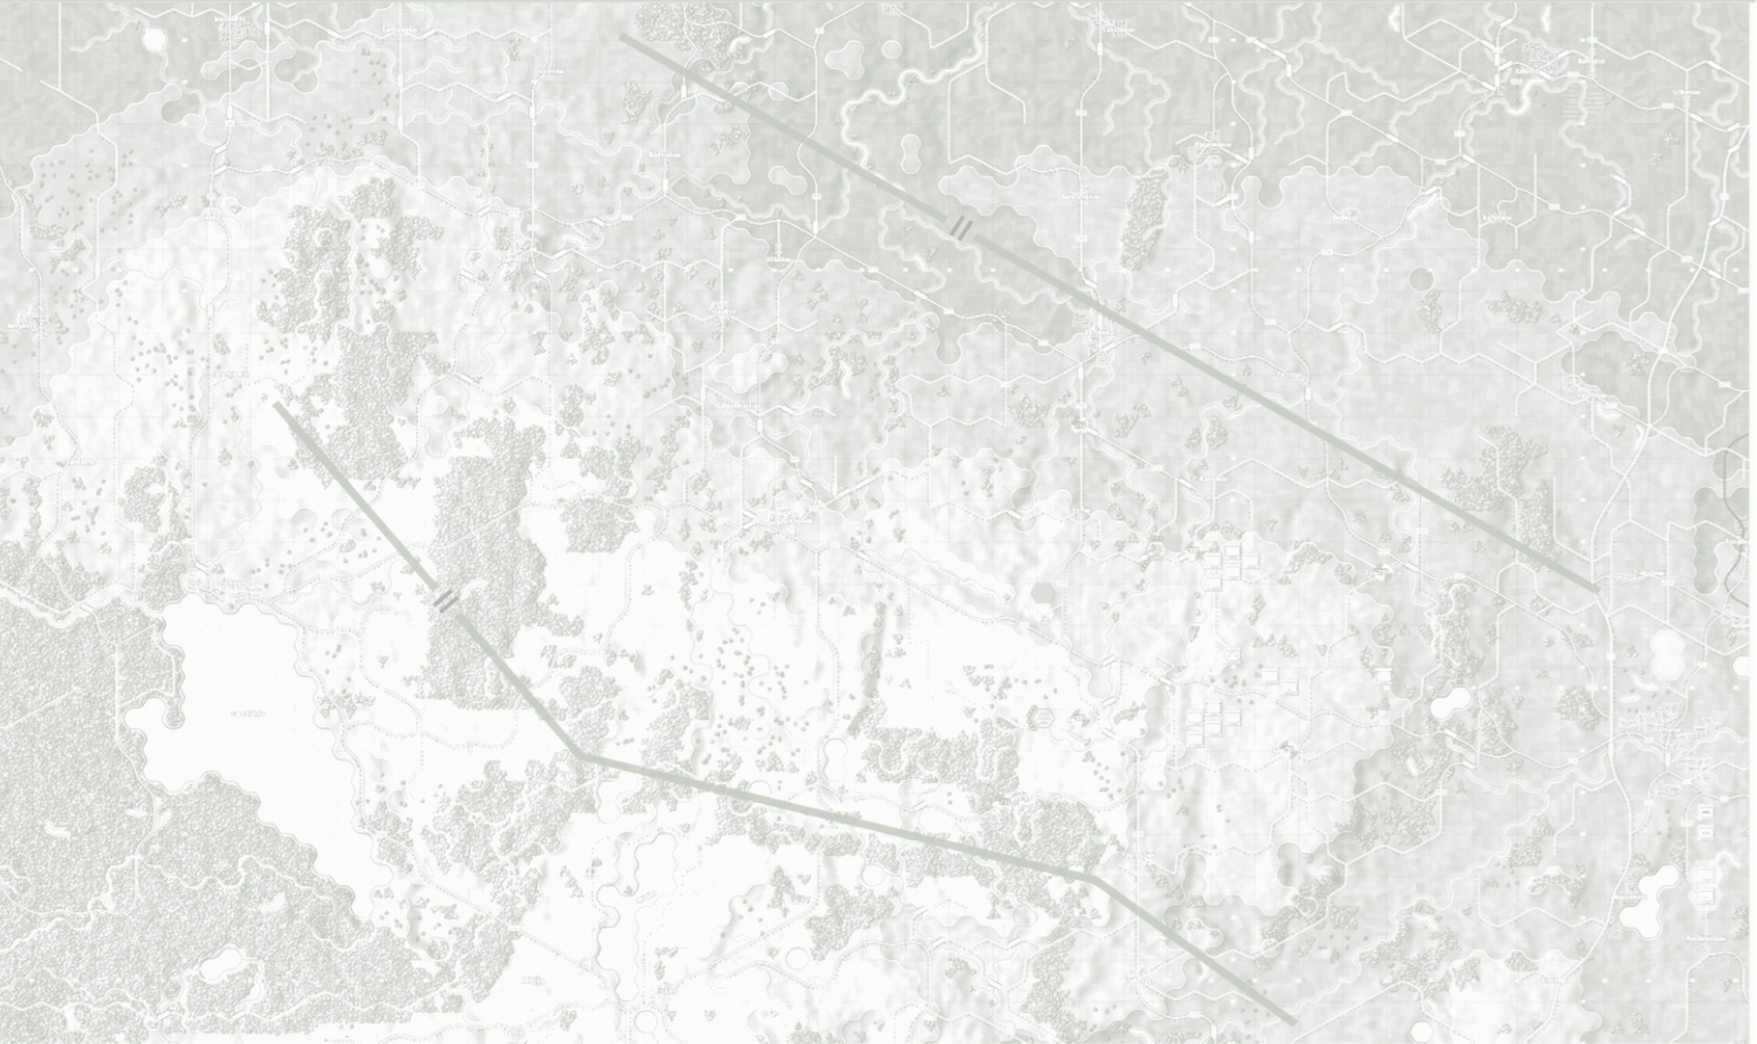

Game FAQ

August 2025

**© 2025 On Target Simulations (OTS), LTD. All Rights Reserved. The images used and OTS Logo are property of On Target Simulations, LTD. All other marks and trademarks are the property of their respective owners.**

Table of Contents

1 Understanding this FAQ 4

2 MAC OS and Linux Support 4

3 32-bit OS Support 4

4 Windows 10 64-bit Support 4

5 Localizations 4

6 Steam Deck Support 5

7 Steam Features 5

7.1 Workshop 5

7.2 Achievements and Trading Cards 5

8 Custom Hotkeys 5

9 Backward Compatibility 5

10 Incompatible 3rd Party Software 6

11 Other Game Crash Sources 6

12 Controller Support 7

13 Discord Channels 7

14 Flashpoint Campaigns Credits 8

14.1 On Target Simulations 8

14.2 On Target Simulations Content Team 8

14.3 Cold War Beta Testers 8

14.4 Matrix Production Support 8

15 OTS on the Web 9

# Understanding this FAQ

To answer questions in advance on various topics that we either don't control or can't support, we have created this FAQ document with the answers already prepared.

Please review this FAQ and its topics. We will often delete threads on the various forums covered in this document to keep the forum content focused on the game and any questions or problems players are having.

# MAC OS and Linux Support

* As much as it would be great to support native code for these two OS platforms, our small team does not have the time or expertise to make these builds and, more importantly, provide technical support for these two lesser-used game platforms.
* There are ways/emulators to make the game work on these two platforms, and tech support on that will be by the community more than by us for the same reasons above.
* If our capabilities change in the future, we will be more than happy to produce a native version and support it.

# 32-bit OS Support

* To better support larger scenarios and other needs in the game engine, we have moved to a Windows 64-bit build of the game engine. 32-bit (effectively Windows 7 and earlier) are no longer supported.

# Windows 10 64-bit Support

* The game ran fine on this platform as recently as August 2024; however, Microsoft no longer officially supports any version of Windows 10 and so we cannot either.

# Localizations

* Since we don't have the time to do the ports to Mac and Linux, Localization and the changes to the UI and code to support that endeavor are out of the question as well for our small team and limited time.
* We want to be able to focus on adding more content and features and doing bug fixes to the base game engine with the time and team we currently have.

# Steam Deck Support

* Due to the limited vertical resolution on the Steam Deck (800 pixels), our game will not display in a usable fashion. We require a 1080 minimum vertical resolution.

# Steam Features

* In general, Steam is one avenue of sales for the game, and we need to have a way for all players to utilize any created content or official DLCs. We can revisit the following Steam-specific items if we find ourselves with additional time and resources.

## Workshop

* There will be no initial support for the Steam Workshop at release. We are looking at what it will take to add the supporting code and interfaces to make this happen sometime after release.

## Achievements and Trading Cards

* We are not looking to do these for the series, and there are other features and content that we see as needing our time and effort. Sorry.

# Custom Hotkeys

* Due to many hotkey assignments in the game and referenced throughout our extensive documentation, we do not allow the remapping of hotkeys in-game.
* There are means of doing this externally if you need it. There is also a risk of crashing the game with an external key mapper. FYI.

# Backward Compatibility

* As much as we would have liked to stay backward compatible with older Flashpoint Campaigns games, the sheer number and scope of changes and new features made that impossible.
* That's both good and bad news.
  + On the bad side, none of the scenarios, maps, campaigns, or even data from older games are forward compatible.
  + The good news is we have expanded the functionality of the game engine and worked to include some player-suggested features to the long list of things we wanted to do with the new game engine.

# Incompatible 3rd Party Software

* Software to shut down if crashing occurs loading the game.
  + While we try to be as careful as possible with our coding and tools used in the game engine, some 3rd party software that hooks into other software to do several audio and visual post-processing routines can crash the game.
  + These also include programs that add overlays to your games, like the Steam Overlay.
  + Currently, the list is as follows:
    - Raptr
    - Riva Tuner
    - MSI Afterburner
    - Nahimic
  + If you see odd CTDs (crashes to desktop), try disabling these packages if you have them.

# Other Game Crash Sources

* Other items to check if you are experiencing game crashes or load failures.
  + **Unused game controllers** - It is a good idea to unplug these if you are not using them. In some cases, an uncentered stick/pad can send the game/OS live input signals that can cause weird map movement to system crashes.
    - If you see a strange map or cursor movement, you may need to disable unused controller drivers (like 3Dconnexion).
  + **Verify your game files** - Make sure you have all the files, and none are missing or corrupted. This also includes making sure you have all the redistributable libraries. Steam has a handy feature for this. If you are not on Steam, try uninstalling and reinstalling the game.
  + **Latest drivers loaded** – Make sure you have the latest and greatest drivers for your audio, video, and controllers.

# Controller Support

* None. Flashpoint Campaigns is a mouse and keyboard-based game given all the information and needs to perform point-and-click operations.

# Discord Channels

* Matrix has a Discord channel. They have also made a dedicated Flashpoint Campaigns Discord channel. If you have an issue or game-related question needing an answer, please use the game's forums on Matrix and Steam. Thanks.
* While Discord offers a means to chat, you need a full-time Dev on the channel to catch any questions/suggestions/bugs, and the format is too freeform to allow decent capture of issues or bugs.

# Flashpoint Campaigns Credits

## On Target Simulations

* Lead Programmer and Head Honcho: **Robert "Ironman" Crandall**
* Data, Programming, Graphics, and Sound: **Jim "Cap’n Darwin” Snyder**
* Programming, Data, Models, and Research: **Jeff “Iron Mike” Sugden**
* Map Master, Programmer, AI, and Graphics: **William van der Sterren**
* Quality Czar and Testing Lead: **Charles “The Whip” Belva**
* Programming: **Kevin “SgtZDog” Zemon, Will Jackson, Alex Kriesel**
* Testing: **Tomasz Niedzinski**

## On Target Simulations Content Team

* Alexander “Stimpak” Schwarz, David “22sec” Whitt, Mike “MikeJ19” Johnstone, Joao Lima, Jurrie van der Zwaan, John “JohnO” Osborne, Jorgen “Jotte” Torgersson, Jo van der Pluym, Scott “WABAC” Gibbs and Steve “Mad Russian” Overton

## Cold War Beta Testers

* To be added before release

## Matrix Production Support

* **Erik Rutins, Maxim Klose-Ivanov**

# OTS on the Web

Matrix Games Forum: <https://www.matrixgames.com/forums/viewforum.php?f=10149>

Check Us Out on Discord: <https://discord.com/channels/911711314051739659/911711314257248331>

Check Us Out on Steam: *“Pending a page URL*”

**© 2025 On Target Simulations (OTS), LTD. All Rights Reserved. The images used and OTS Logo are property of On Target Simulations, LTD. All other marks and trademarks are the property of their respective owners.**